**Introduction**Here in this project various tables are created in the database of an office. There is a ***EMPLOYEE*** table where basic information of employee is stored also specifying the department number of the employee. There is a different table named ***PROJECT*** where all the information about certain project is shown in tabular form and the department to hold that project is also stored here. ***WORK_IN*** table contains information about employee specifying the project they are working on and hours they have been working. There is also a ***DEPARTMENT*** specifying the information about the departments.

Here various attributes are found to be interconnected and with creating these tables we can find study and use the relation in future which will increase our knowledge with SQL and database system.

|  |
| --- |
| Inserting Data |
|  |

|  |
| --- |
| Tabular View |
|  |

Various queries are solved with the tables created above.

This is a Query to display employee number and name of those employee whose salary is more than 4000.



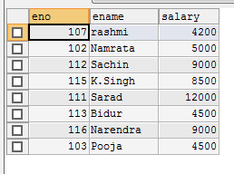

Following query display name and number of employee whose salary is more than 4000 and job status is professor.



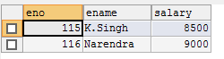

This is a query for those employees whose age is between 24 and 28 and display eno, ename, age, salary of those employees.



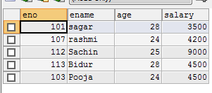

This is Query for those employee whose name start from sa.



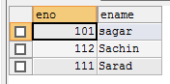

This query prevents from data repetition from various table of database.



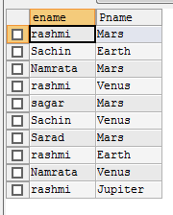

**Conclusion**

Here our knowledge on database and SQL system in more elaborated with a example of very good database. Here various attributes are found to be interconnected and with creating these tables we can find study and use the relation in future which will increase our knowledge with SQL and database system. Data are easy to survey in the organized tabular form.